**PROJECT 1 REPORT**

**TEAM 45**

**KATHRYN ATHERTON**

**JOSHUA HAHN**

**HANNAH MACKIN SCHENCK**

**EXECUTIVE SUMMARY**

The team was tasked with designing a mousetrap car to perform in a Tug-of-War competition and pull a 200-gram sled as far and fast as possible while minimizing the weight of the car system. Materials supplied included two mousetraps, two small paper clips, and two large paper clips. Any other materials the team used were limited to a budget of $8, including tax.

The final design of the car is composed of sturdy plastic building pieces for the body, CDs for the wheels, plastic Meccano rods for the axles, and zip ties and duct tape to secure the various elements into a single car. Fishing line was used as the means to transfer energy from the mousetrap to the axle. The line was tied directly to the mousetrap arm. A loop on the other end of the line was attached to a zip tie “catch” on the axle, such that when the mousetrap returned to its starting position the loop would detach and the axle could continue to rotate. The line would then be wound around the axle as the mousetrap was pulled back and set. In order to maximize pull on the axle, the mousetrap was positioned directly above the axle. A hair tie was used to increase the energy the mousetrap provided to the system. Balloons were cut and wrapped around the CDs to provide extra friction between the wheels and the ground and prevent slippage during competition. The overall cost of the car was $4.89.

In the Tug-of-War competition, the mousetrap car won its first match, lost its second match, won the next three matches, and finally lost in the championship round. A unique aspect of the design in competition was sustained pull. A few teams were able to pull the car a few inches, but they quickly ran out of power and the car was able to pull back the other way.

In the sled-pull demonstration, the mousetrap car pulled the 200-gram sled 11.375 inches over 2.25 seconds. Due to the 268-gram weight of the car, the score for this portion of the demonstration was 0.0189. Although the weight of the car detracted from the sled-pulling aspect of the competition, it was an advantage in the Tug-of-War competitions, as teams were unable to pull the car backwards.

**DESIGN CONSIDERATIONS**

The first thing the team did after receiving the task was to create a Gantt Chart to schedule its progress in the project (Figure 1).

**Figure 1: Gantt Chart**

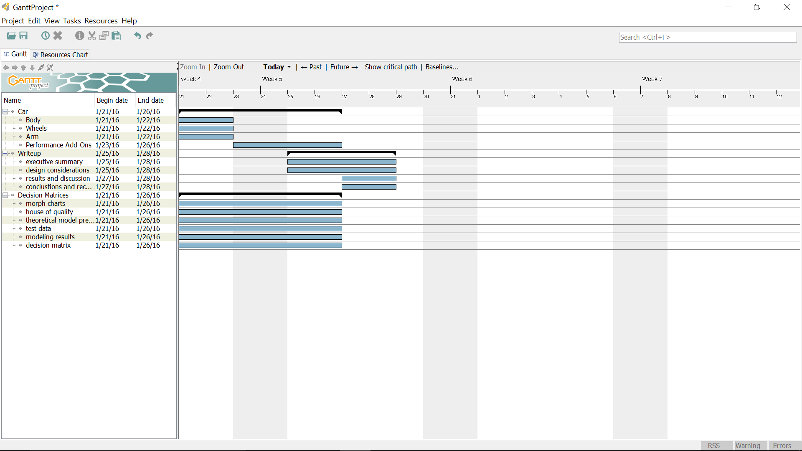

Once a basic agenda was created for the project, the team began to produce technical needs, technical requirements, and target values for the needs required by the project (Table 1).

**Table 1: Engineering Specifications**



Finally, based on the requirements and target values, means to meet these values were brainstormed in a morph chart (Table 2).

**Table 2: Morph Chart**



One important design element of the car was the frame. The body of the car was designed to be light, yet sturdy. It was decided to use a Meccano set, which cost $25 for a set of 100 pieces, and zip ties, which cost $1.98 for 100, to construct the body of the car, as the individual pieces were inexpensive and allowed the team to easily and rapidly construct different designs for the frame. The basic design involved securing two long plastic struts (Figure 2) with plastic blocks (Figure 3).

**Figure 2: Meccano Plastic Struts**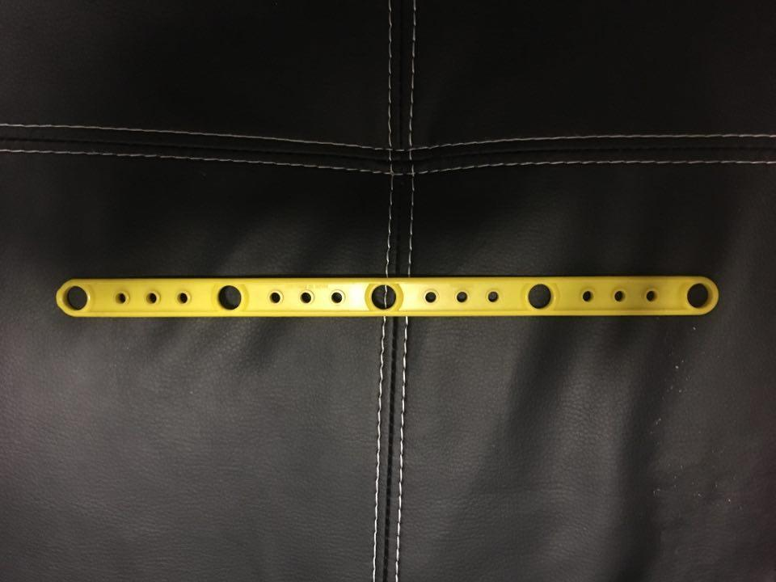

**Figure 3: Meccano Plastic Block**

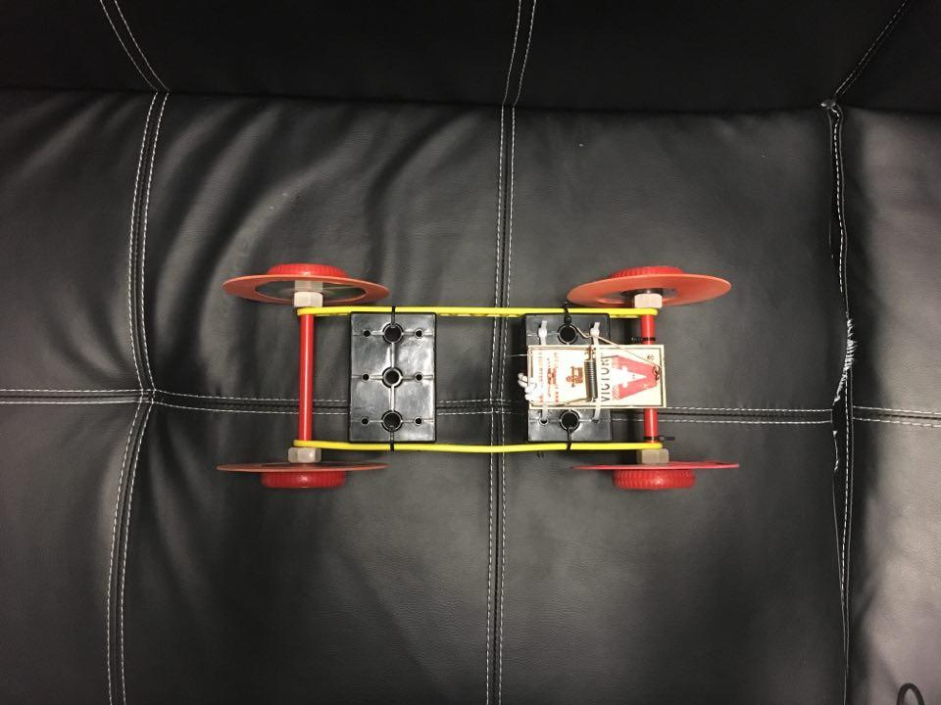

The team considered two alternatives: using two blocks and using only one block. After building both designs were constructed, the team noticed that one block did not provide enough support to maintain a sturdy frame. Although using two blocks was heavier, the vehicle was sturdier. In addition, two blocks (Figure 4) allowed for more options for mouse trap placement, which would be important in other stages of design.

**Figure 4: Final Frame**



Next the design team considered alternatives for the wheels. The team considered using wooden wheels, 3D printed wheels, and CDs. The wooden wheels were determined to be too heavy, and the 3D printed wheels were not expected to be able to be produced before the demonstration date. Hence CDs were determined to be the best alternative, as they were perfectly circular, light, rigid, inexpensive ($0.17 each), and offered a high wheel-to-axle radius ratio, which allow the car to move a further distance with the same number of rotations. The issue discovered with the CDs is that they did not offer sufficient friction with the ground. To solve this issue, the team considered adding a cover to the outside of the CD to improve friction. Balloon “tires” (balloons cut to create a thin rubber loop, Figure 5) and rubber bands were determined to be possible materials.

**Figure 5: Balloon Tires**

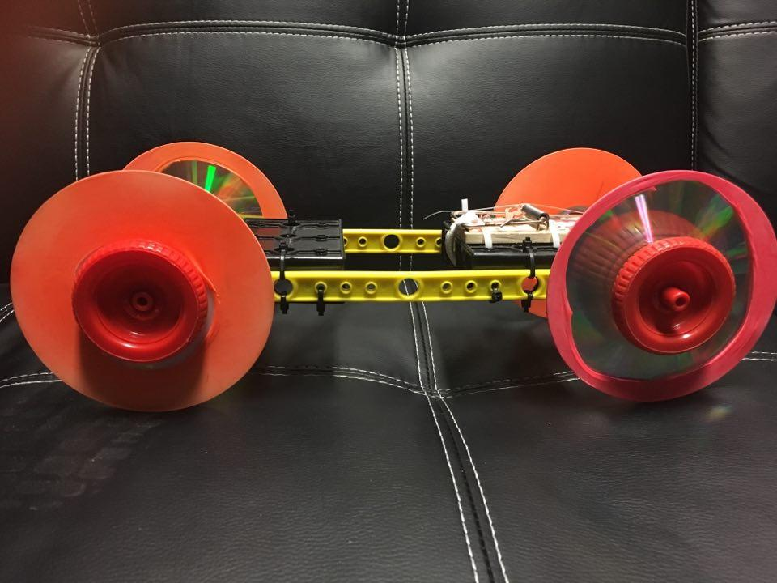

After testing (Table 3), CDs with balloons were determined to be the best wheel alternative, as they were the most reliable. These cost $0.06 each.

**Table 3: Wheel Covering Performance Data**

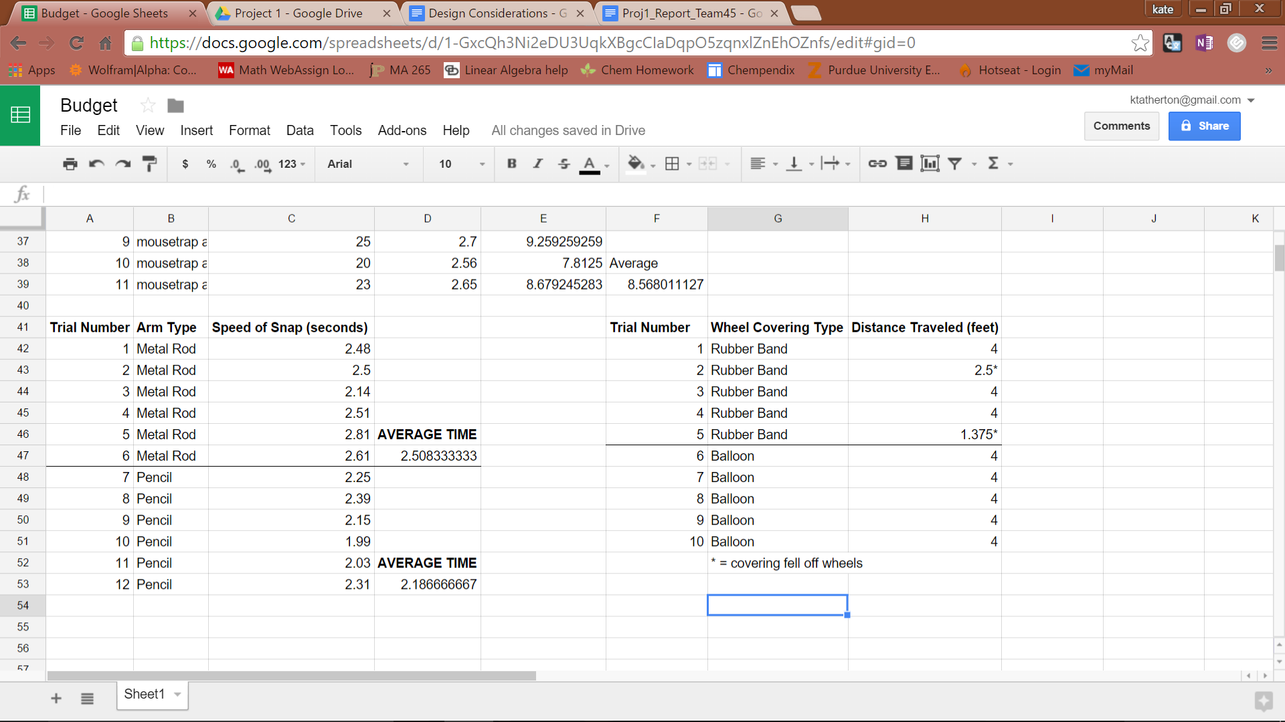

Next, the team designed the pulling system for the mousetrap car. A functional block diagram (Figure 6) was generated to help identify various elements of the pulling system.

**Figure 6: Functional Block Diagram of Pulling System**

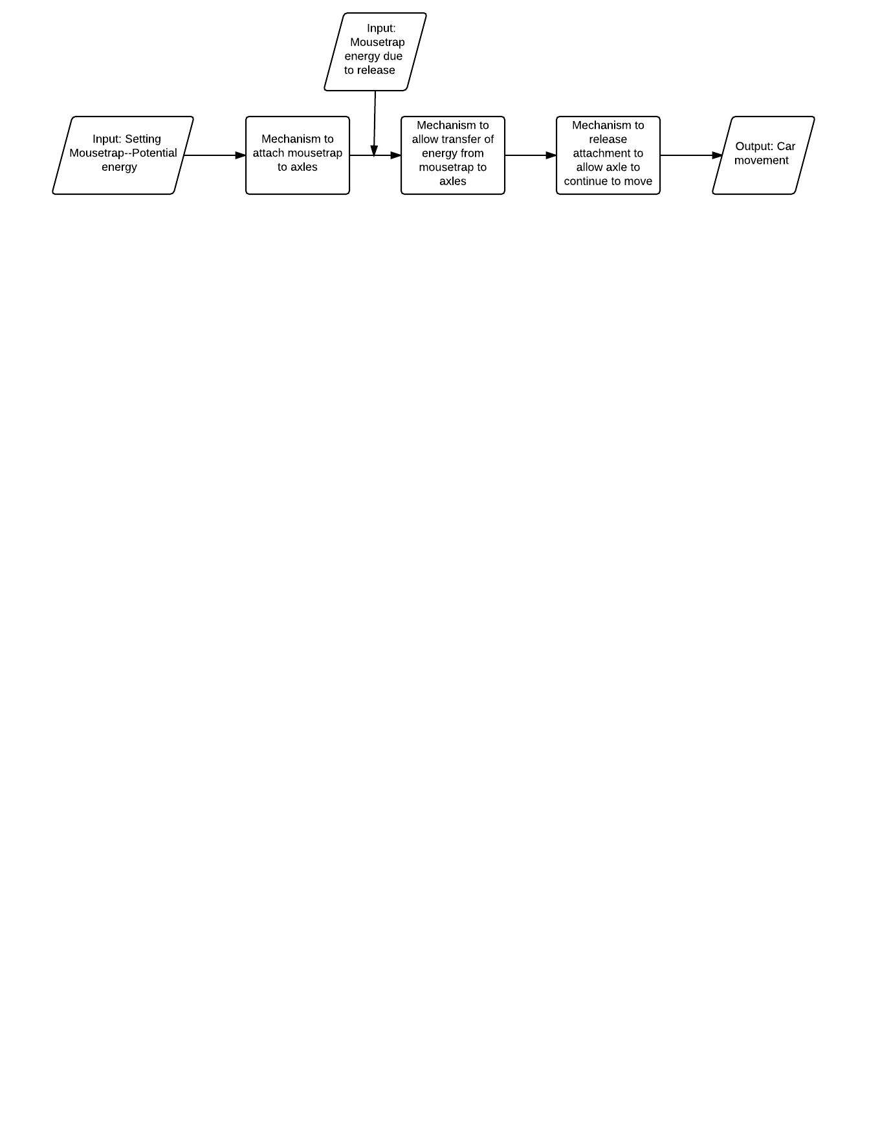

After constructing the functional block diagram, the team went about designing an axle that would accomplish these tasks. A plastic Meccano rod (Figure 7) that fit well into the frame and through the center of the CDs was used as the axle.

**Figure 7: Plastic Meccano Rod**

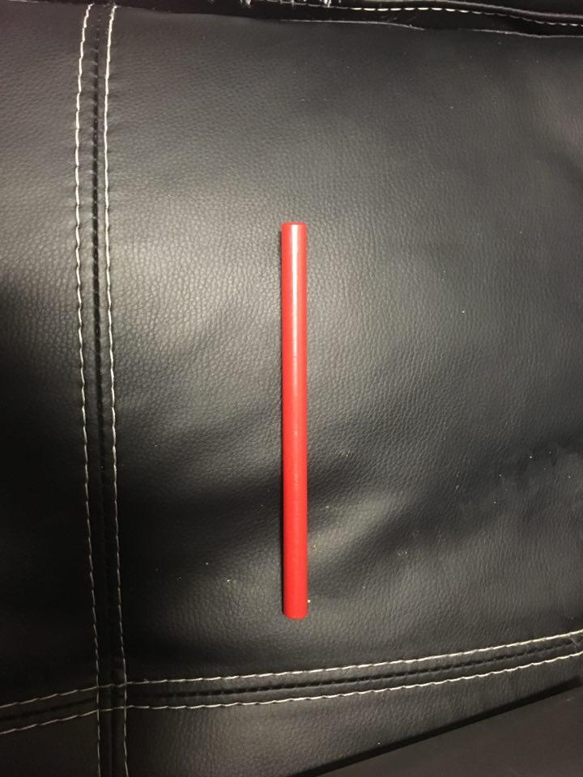

Meccano nuts and bolts were used to secure the CDs onto the axle and frame. Next, the team needed to come up with a way to connect the axle to the mousetrap. In order to accomplish this, a zip tie (Figure 8) was added to the axle, such that a loop of string could hook onto it and allow the string to wind around the axle was the mousetrap was set.

**Figure 8: Zip Tie Catch**

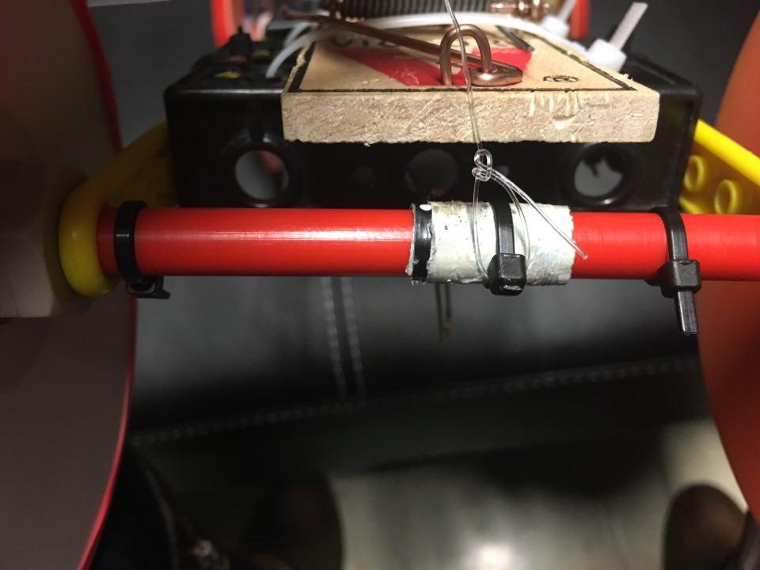

The other end of the string would then be connected to the mousetrap in some fashion, allowing energy to transfer from the mousetrap to the axle. Various types of string were considered. The team had thread, 10 lb. fishing wire, and 30 lb. fishing wire. The thread was ruled out after it broke during testing, as the team wanted to ensure that the string was durable so that the car would not malfunction during competition. Keeping this in mind, the 30 lb. fishing wire, which cost $0.04 per yard, was selected for the string. Although it was slightly more difficult to tie, this added an extra factor of safety into the design.

The final aspect of the design was modifications to the mousetrap itself. When beginning to design the pulling system for the mousetrap car, it was decided that a long pulling radius would be most advantageous for the competition, as the energy of the mousetrap car would be conserved for as long as possible, thus outlasting the competition. Two different types of arms were considered: pencils and metal rods. Pencils were ultimately decided on because they were lighter than the metal rod. Although the metal rod was sturdier, the mousetrap arm pulled slower because of its weight (Table 4).

**Table 4: Mousetrap Arm Pulling Data**

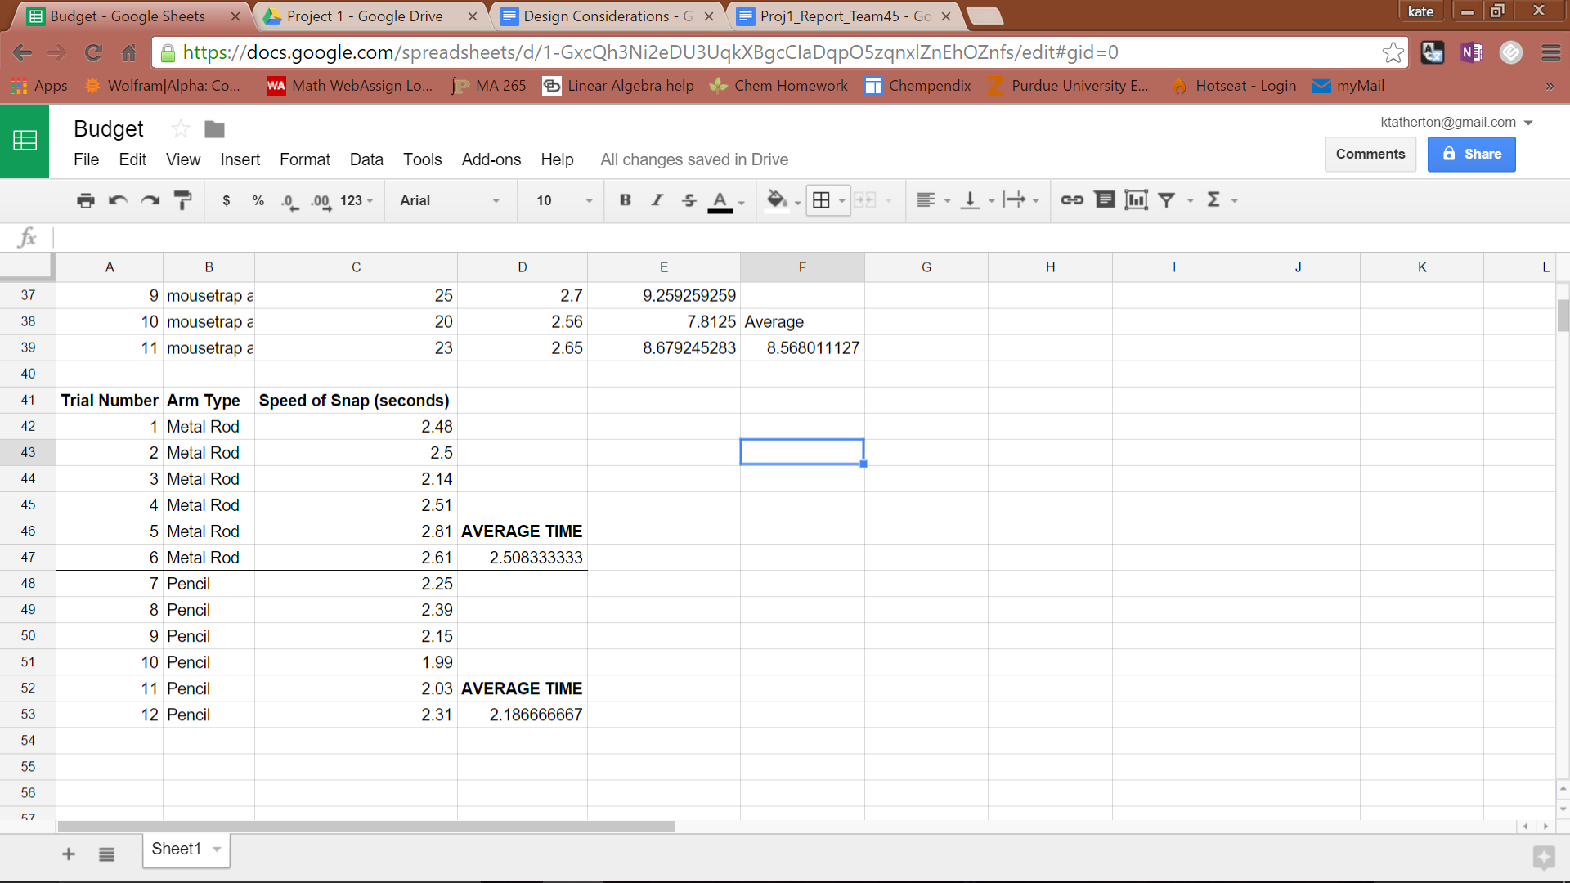

Pencils were then attached to the mousetrap using duct tape and zip ties. The mousetrap was positioned towards the front of the car such that when the mousetrap was set, the ends of the pencils were directly above the back axle, thus optimizing the pulling force once the mousetrap was sprung.

After testing the car with a weighted sled like the one used in the sled-pull demonstration, it was found that the longer pulling arm did not allow the car enough power to overcome the friction between the sled and the ground. Various attempts at optimizing the pencil arms were used by moving the mousetrap back on the car and attaching the string further down the pencil in order to shorten the pulling radius. However, none of these designs had the power to move the 200-gram sled (Table 5).

**Table 5: Mousetrap Arm Length vs. Distance Traveled with 200g Sled**

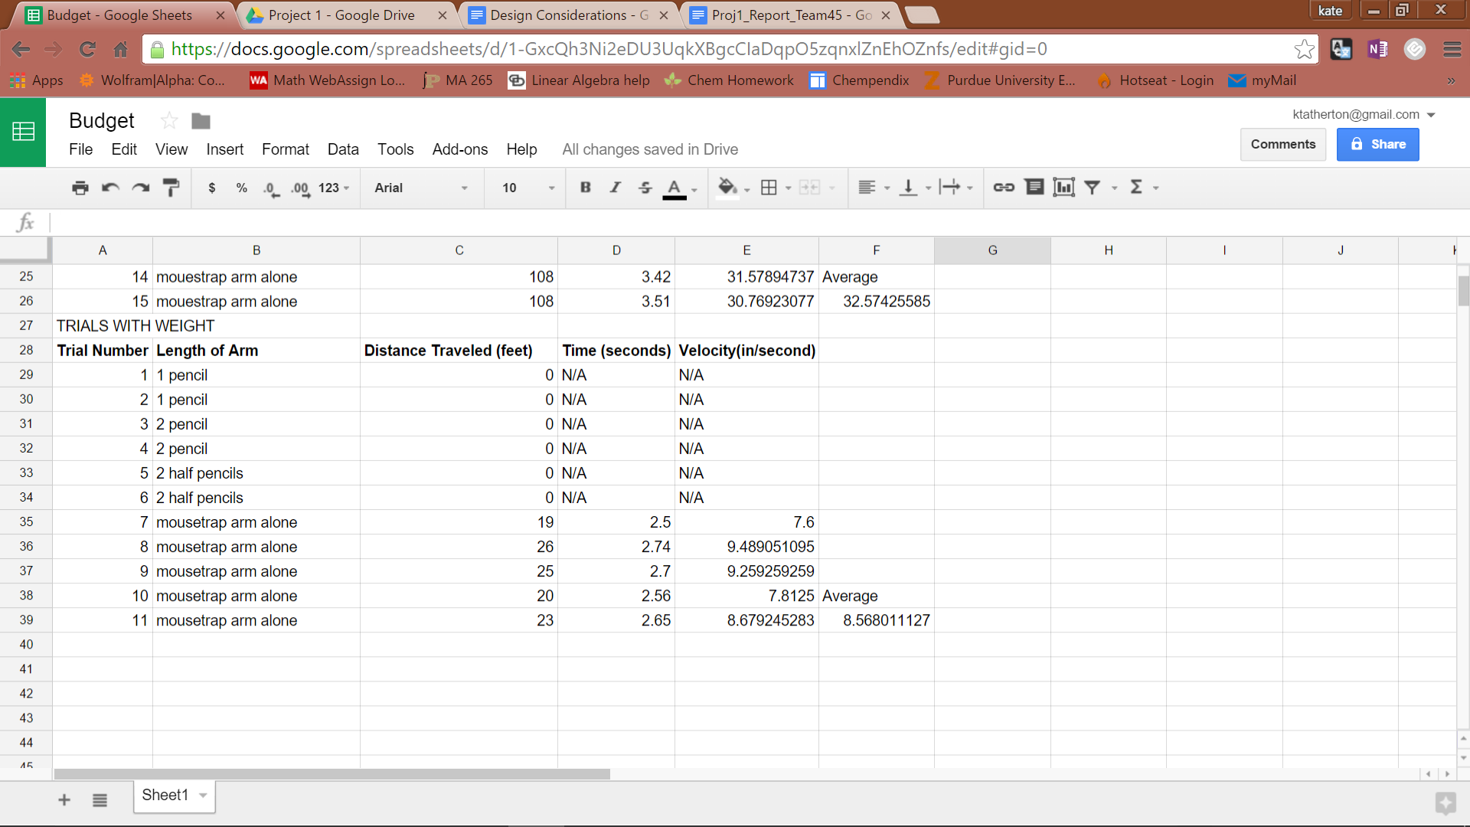

After testing (Table 6), the team noticed that a shorter pulling radius increased the power at which the car was pulled.

**Table 6: Mousetrap Arm Length Vs Distance Traveled without 200g Sled**

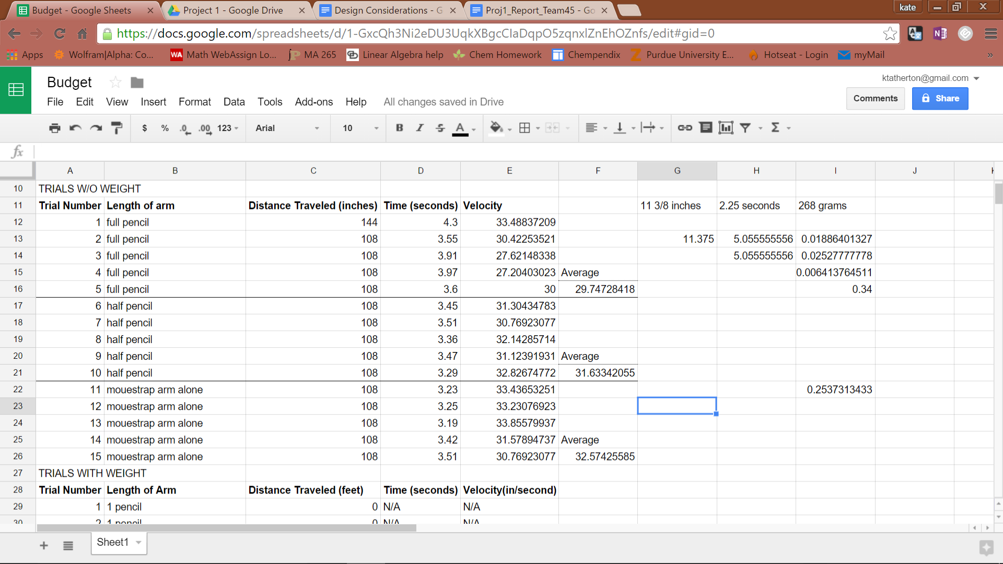

Therefore, the pencils were removed and the mousetrap arm alone was used as the pulling arm.

The final mousetrap car design (Figure 11) included the body design previously described and fishing line attached to the mousetrap arm to act as a pulling arm. Two unique aspects of the design were the addition of a hair tie, which cost $0.09, to the mousetrap arm, and duct tape, which cost $0.17 per yard, to the back axle. The hair tie (Figure 9) was attached to the mousetrap arm then zip tied to the Meccano block underneath the mousetrap so that when the mousetrap was set, the hair tie would pull on the mousetrap in the snapping direction, adding extra energy to the system.

**Figure 9: Hair Tie Placement on Mousetrap Car**

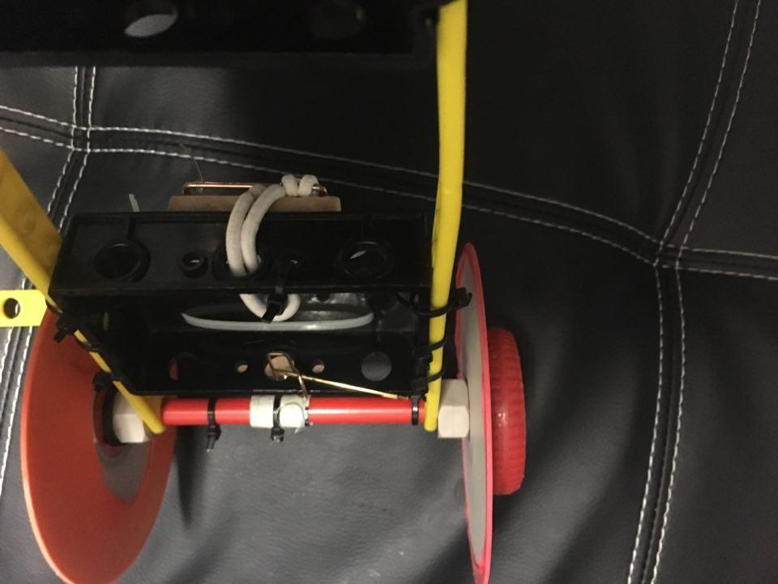

The duct tape (see Figure 8) was placed around the back axle to improve the grip of the fishing wire on the axle, allowing a more efficient transfer of energy from the mousetrap to the axle movement and preventing slippage on the axle.

**Figure 10: House of Quality Decision Matrix**

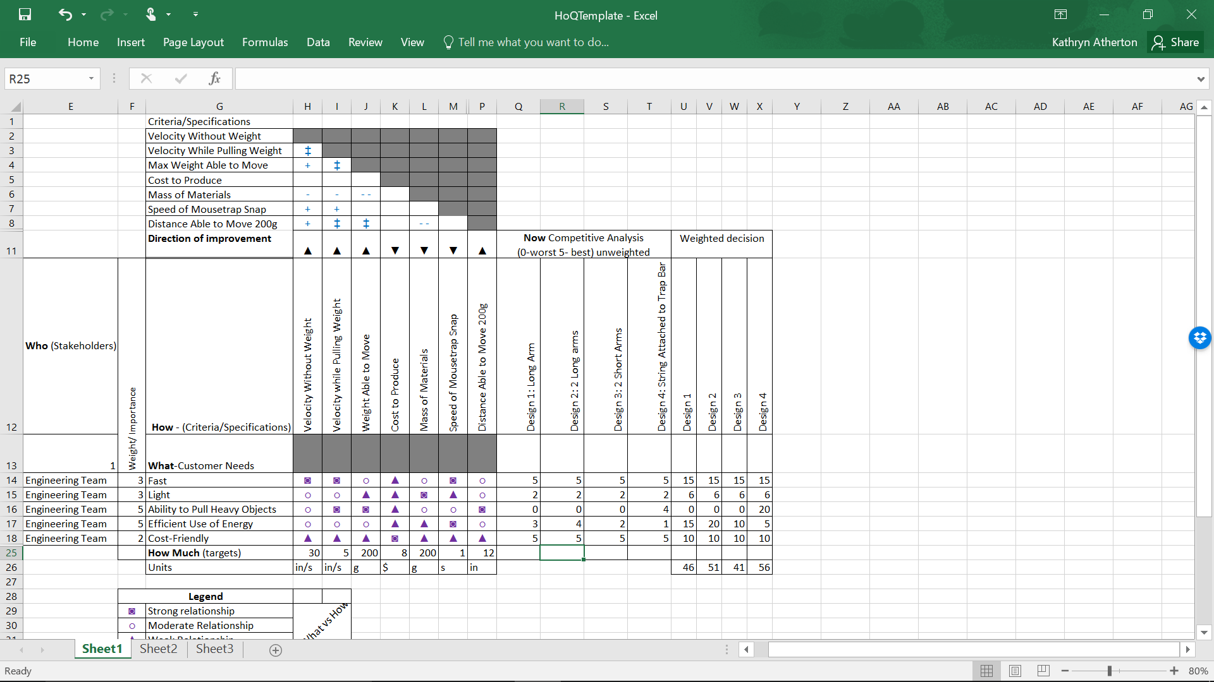

**Figure 11: Final Mousetrap Car Design**



In total, the team used 14 Meccano pieces, four CDs, four balloons, 22 zip ties, 1/9th of a yard of fishing wire, 1/9th of a yard of duct tape, and one hair tie. The total cost of the mousetrap car system was $4.89 (Table 7), which fell well below the $8 budget.

**Table 7: Final Budget**

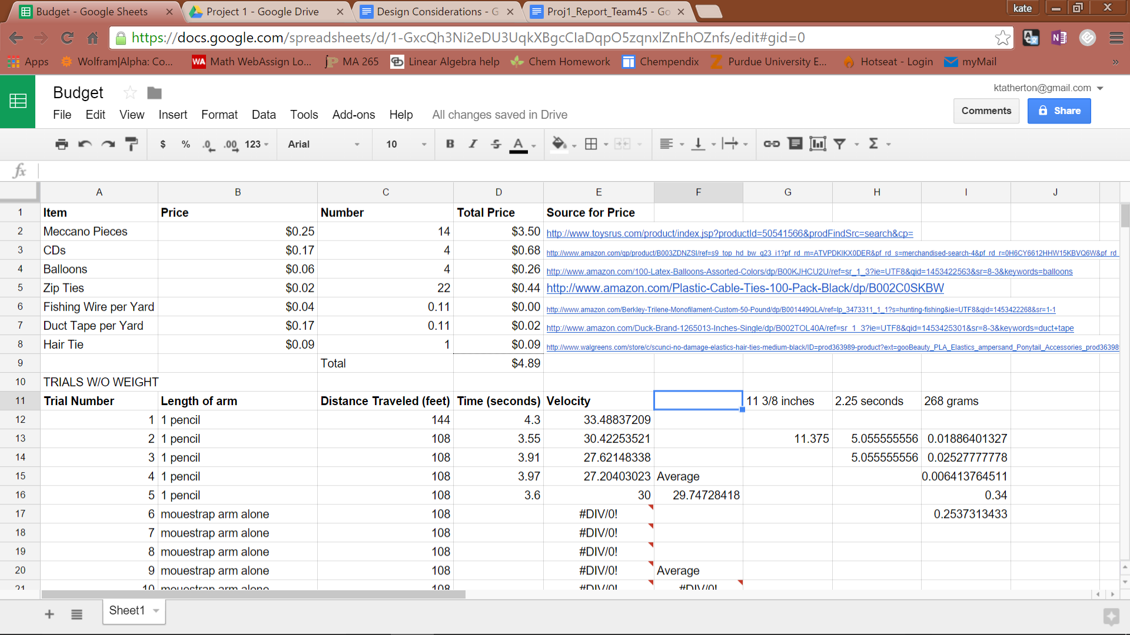

**RESULTS AND DISCUSSION**

The mousetrap car was evaluated based on its performance in a Tug-of-War competition, as well as a sled-pull demonstration scored using the formula *score = (D/t) ⁄ M* where D is the distance the 200-gram sled is pulled in inches, t is the time it takes to pull the sled in seconds, and M is the total mass of the mousetrap car system. In the Tug-of-War competition, a team was eliminated after losing two matches. Scores for this portion were based upon how far in the competition bracket a team’s car progressed.

The team believed the mousetrap car would not progress very far in the Tug-of-War competition. This was due to the short length of the pivot arm, which was believed to be so short that it would run out of energy before its competition did, thus leading the car to be pulled backwards by the other car. It was also believed that the mousetrap car would be able to move the 200 gram sled a distance of at least 18 to 20 inches in about 2.5 seconds, as shown by testing prior to the final demonstration.

In the final demonstration, the mousetrap car progressed to the final round through the consolation bracket, after losing its second match to the ultimate victor. In total, the car participated in six different matches, winning four and losing two, both losses being against the final victor. This performance was much better than the team expected. This performance was due to the power that the short arm offered as well as the high mass of the car compared to the competition. It was observed that the car pulled for a longer period of time than the competition, and that the car was too powerful and massive for other cars to overcome.

In the final sled pull, however, the mousetrap car did not perform as well as was expected. The car pulled the 200 gram sled a distance of 11.375 inches over 2.25 seconds. It was observed that the mousetrap arm did not fully snap once released, thus preventing the car from pulling the sled the expected distance. It is believed that the loss of power during this portion of the demonstration can be partially attributed to the stretching of the fishing line, which absorbed some of the energy from the mousetrap. The final score for the mousetrap car in the sled pull was 0.0189.

**CONCLUSIONS AND RECOMMENDATIONS**

Overall, the mousetrap car performed well. It was found that the short arm on the mousetrap works much better than the team had expected, and allowed the team to progress far in the Tug-of-War tournament bracket. The downfall of the design was its weight. The car was so heavy that the sled-pull demonstration score was much lower than the team had expected. Thus, the team recommends finding lighter materials for the frame of the car in future design improvements. By reducing the weight of the car, the score of the sled-pull demonstration would be much greater than 0.0189. To remove 25% of the current weight of the car would increase the sled-pull score by 34%, assuming that the performance remained the same.

Other recommendations for future design improvements include replacing the fishing line and mousetrap before competition in order to prevent a loss of potential energy before the competition even begins. By replacing the fishing line, there would be less stretching of the wire during the snapping of the mousetrap, allowing for a more efficient transfer of energy from the mousetrap spring to the movement of the axle. Along the same lines, by replacing the mousetrap, the spring would be tighter, as it was not stretched over and over again during testing. This would create more potential energy from the mousetrap, and increase the pulling power the car has.

**REFERENCES**

Atherton, K., Hahn, J., & Mackin Schenck, H. (2016, January 28). Mousetrap Car Challenge, Team 45. Retrieved January 28, 2016, from https://youtu.be/hCnFPmW3sNo